User-centered Design Process Report By

Group name - Anxiety
Kyawt Eaindray Win-6509790
Yu Ya May - 6509832
Wai Hmue Thit - 6509862
Shine Htet Wai Yan -6509910
Thiha Soe - 6509911
Choo Pyae Sone Win-6509944

Enhanced FAQ Page for Admission Requirements of Rangsit University International College

Table of Contents

- Introduction…………………………………………………… 3
- Identify User Need………………………………………… 3
- Define Use Context………………………………………… 4
- Set Requirement……………………………………………. 4
- Design Iteration……………………………………………… 4
- Implementation…………………………………………….. 9
- Usability Testing ……………………………………………. 12
- Evaluate and Refine………………………………………. 13
- Conclusion ……………………………………………………. 14

1. Introduction
Information System Analysis is a crucial part in developing and managing information systems. It involves examining and understanding the information needs of an organization, identifying how technology supports those needs and defining requirements for implementing an effective information system.
Our team is developing an enhanced FAQ page for Rangsit University Admission Requirements to make it more intuitive about what new students who are going to apply to Rangsit University. Rangsit University offers admission not only for local students but also for international students. Our user-friendly interface ensures everyone can see clear and up-to-date information with the new found questions users need to know and navigate effortlessly. With multilingual support and smart AI features, we're dedicated to providing an inclusive and efficient University admission process.
2.Identify User Need
Once after we have implemented our project, we went over students to try our project and request some reviews. According to the reviews, the following are the main factors to improve our coming progress.
- UI needs to be more Dynamic
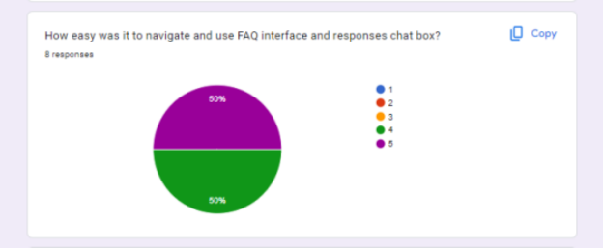
According to the feedback rates, we are trying to enhance our project UI and make it more dynamic, easier to navigate. As we mainly focus for users to ask questions in a box, improve the visibility of the provided questions and AI responses.
- Chatbox Responses and More Information
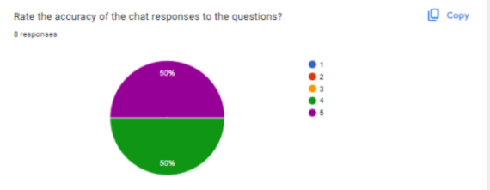
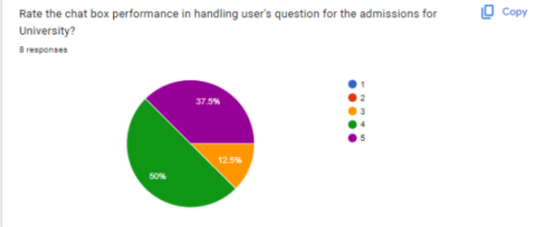
Since we have implemented the Gemini AI to give a response to the users, we have trained AI with a lot of answers, but users still want us to add more information so we will be updating the questionnaire answers that might satisfy the user, faster the response in overall actions.

3.Define Use Context
Baseline testing is a fundamental process for evaluating a system or component’s initial performance and characteristics. Baseline testing for Rangsit University’s Admission FAQ pages involves evaluating how the system is currently functioning. During this testing includes analyzing user interactions, navigation patterns, user queries and overall user experience on the FAQ page. The goal of this is to gather insights into how users interact with the system and identify any usability issues and make decisions for improving the FAQ page’s effectiveness and user satisfaction.
User: The main user of this FAQ page system is prospective students, current students, parents, faculty members, or other stakeholders.
Goals: Main function of this system is to find out about the user's satisfaction. First we need to find out about their seeking information about admission requirements, application procedures, financial aid, or other topics.
Devices: We also need to find out about the device users will mainly use to open this system. This could include desktop computers, laptops, tablets, or smartphones.
Tasks: The most specific task users want the system to perform also need to be analyzed. For example, searching for answers, submitting inquiries, or navigating through different sections.
Expectations: What are users' expectations regarding the usability, accessibility, and content relevance of the current FAQ page and what we need to improve in the current system?
4.Set Requirement
To enhance the Rangsit University International College FAQs page, a comprehensive grasp of the needs, preferences, and pain points of the target audience is required for the User Centered Design Report. Initially, in-depth user research needs to be done in order to determine the demographics, surfing habits, and frequently asked questions of users. Usability testing should also be done to determine how well the present FAQs page is working and to learn what needs to be improved. The report should also include specific design goals for bettering the user experience, like strengthening accessibility features, information clarity, and navigation. It is imperative to incorporate collaborative input from stakeholders, such as administrators, teachers, and students, to guarantee that the final design satisfies the demands and expectations of the Rangsit University International College community.
The Set Requirement entails clear communication and collaboration channels between stakeholders, designers, and users throughout the design process. Establishing regular feedback loops and user involvement sessions will facilitate continuous improvement and iteration of the FAQs page. By fostering an environment of open communication and collaboration, we can cultivate a sense of ownership and commitment towards creating a user-centric FAQs page that serves the needs of both the university community and prospective students effectively.
5.Design Iteration
Our primary concern on this FAQ page is user accessibility and convenience. Our goal is to present a user-friendly website with a clear vision that is accessible to all. It makes use of the larger image display and readable font sizes.


Figure 1: wireframe 1

The wireframe displays the logo at the top of the page, with a subtitle situated next to it. The frequently requested questions are represented by the rectangle shape, which is arranged in synchrony. The answers are given in a box beneath each question that appeared when you clicked the questions. The information is located in the rectangular box beneath the website.
Figure 2: wireframe 2
The chatbot is shown next to the question box in this wireframe. There are two boxes that show when we open the chatbot. The question can be written in the lower area, and the solution can be found in the upper box. The information is located in the rectangular box beneath the website.
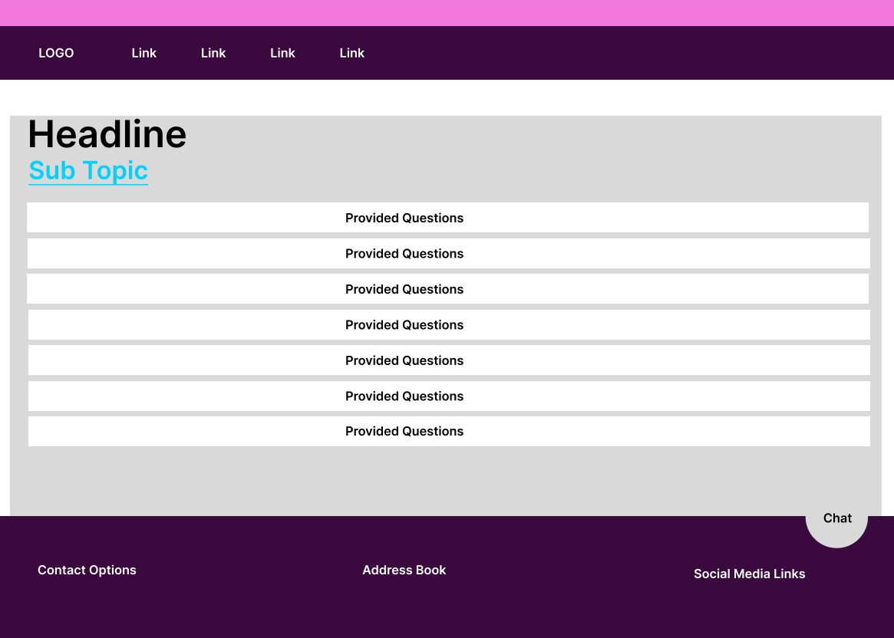
Figure 3: Outline 1
The font size and placement on the website were designed and organized appropriately. The website's logo appears at the top, and links to further sites are provided right next to the logo. To act as the website's centerpiece and alert users that they are on the FAQ page, the headline has the largest font size. The subtitle, which provides further information about the purpose of the website, appears beneath the headline. We have listed the most frequently asked questions by students regarding RSU entry requirements in the rectangular box. To make it readable for everyone, it is written and shown in a large typeface. Contact information is located at the bottom of the page, along with an address book with little text and a social networking link next to the logo. Between the contact options and the address book is a chatbot logo.
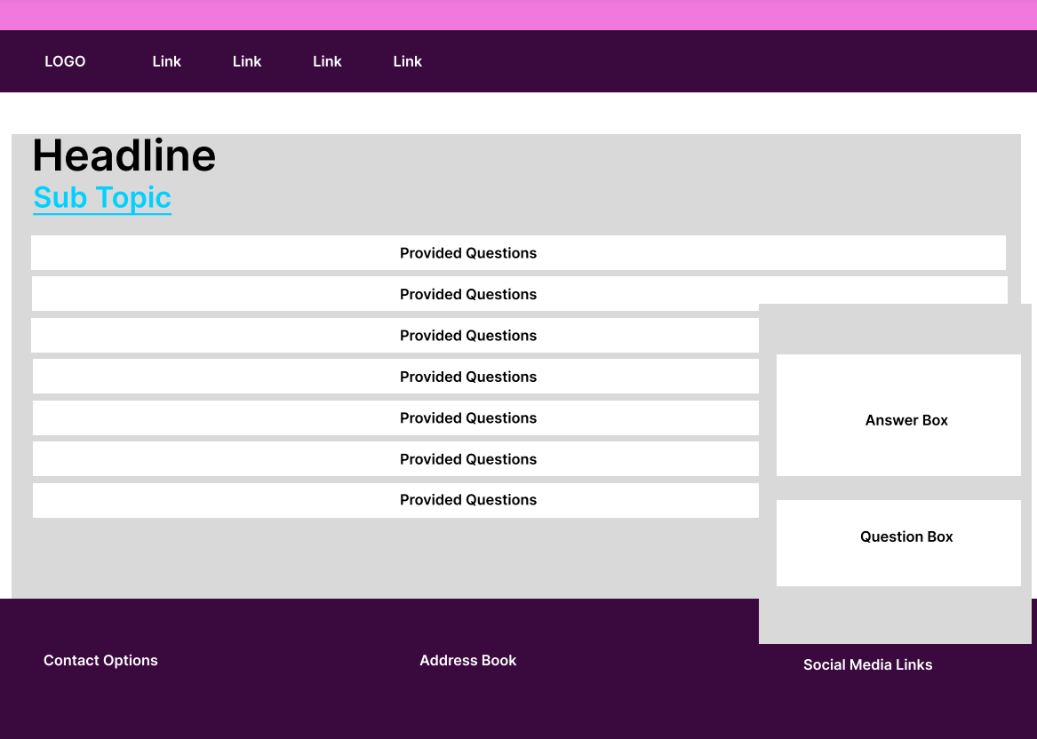
Figure 4: Outline 2
Figure 4 illustrates the chatbot in an open state. There are boxes for questions and answers. The text in both boxes has a readable font and size. The query can be written beneath the response that is provided at the top.

6.Implementation
New Features
- The old system FAQ page for admission requirements of Rangsit University includes the messenger bot in which the webpage links with the messenger of Rangsit University. To be able to ask a question, users need to log in to Messenger first. But in our new system, we implement an AI-supported chatbot. That chatbot can answer in almost every language.
- We train the Gemini AI which is implemented in our system to be an insightful and informative chatbot so new users can explore information about the admission requirements of Rangsit University.
New Designs
- We changed the design of the interface to be more tidy, clean, and user-friendly by providing the answers only when clicking the questions the user would like to know while the old system displays all the questions and answers on the webpage.
- For the chatbot section, our system designed the robot icon in the blue circle to ensure users it is an AI-supported chatbot so they can ask all the questions effectively and efficiently just by clicking the robot icon and typing the questions. After the users provide the question to our system, our system will generate answers that are approved by the admission team of Rangsit University.
The following design is the final interface design of our new system.
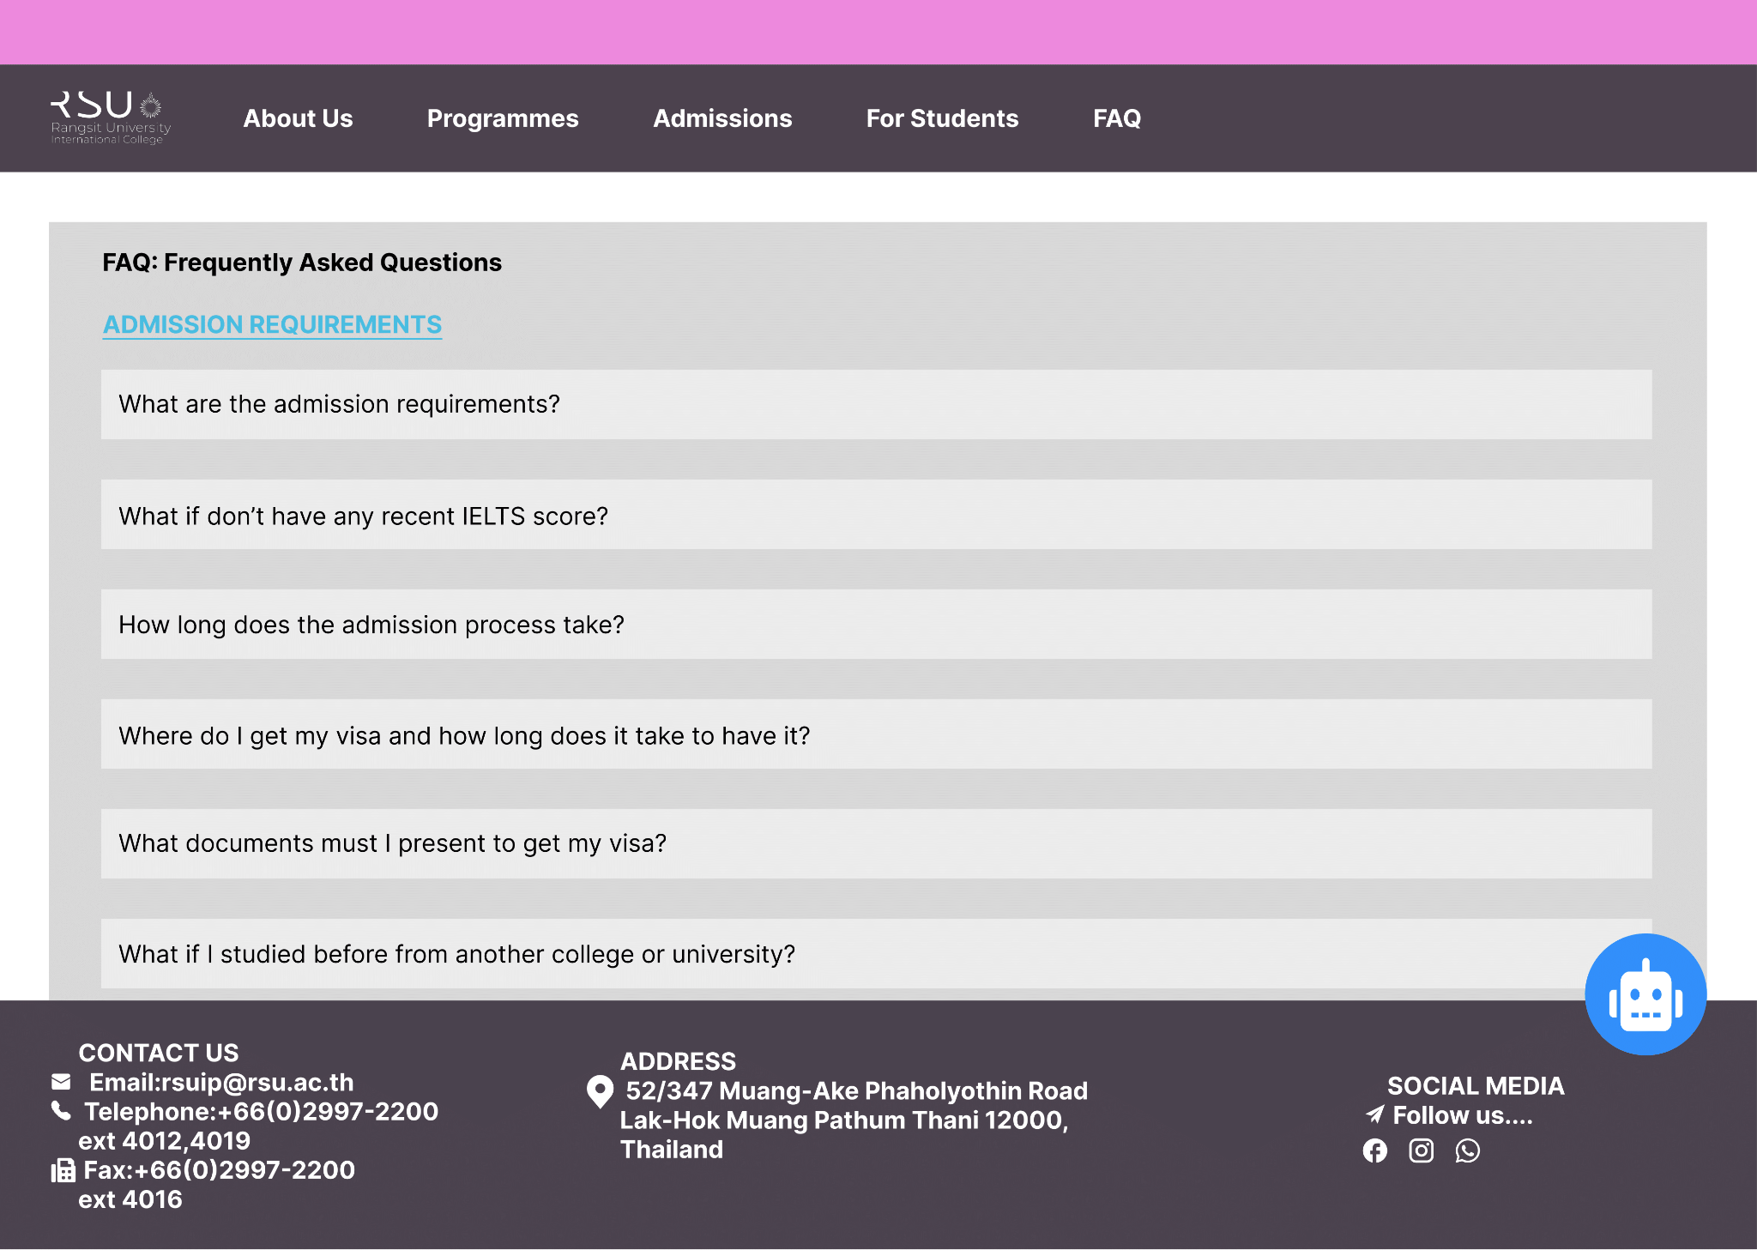
When clicking the chatbot icon, a messagebox will be displayed and users can ask the questions in it.
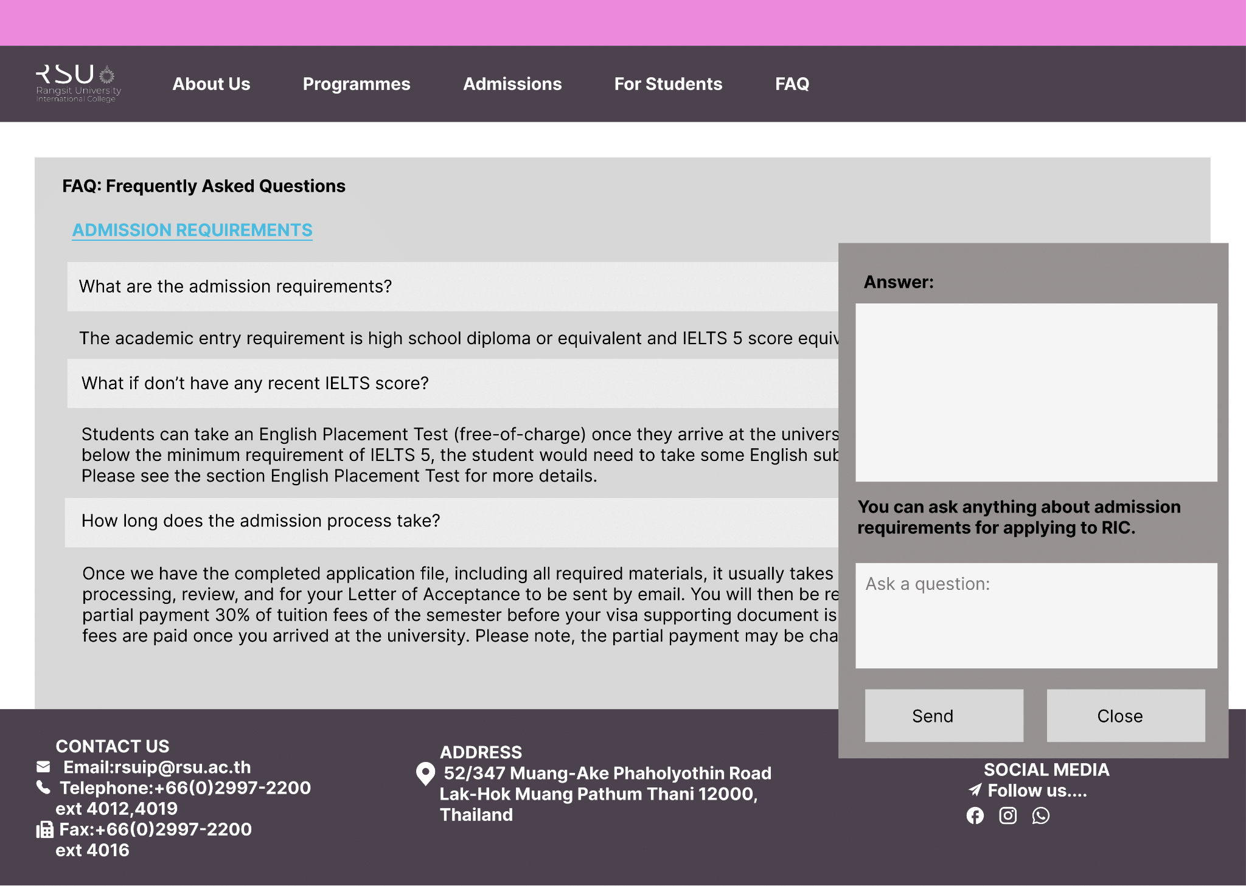

7.Usability Testing
In testing our FAQ page, we aimed to understand how students and parents use it. Our goal is easy navigation and relevant info. With diverse participants, we did one-on-one sessions, watching tasks like finding enrollment info and academic resources. Gathering feedback helped us find areas to improve, prioritizing enhancements for a better user experience. These are some of the user testing of our FAQ page shown below.
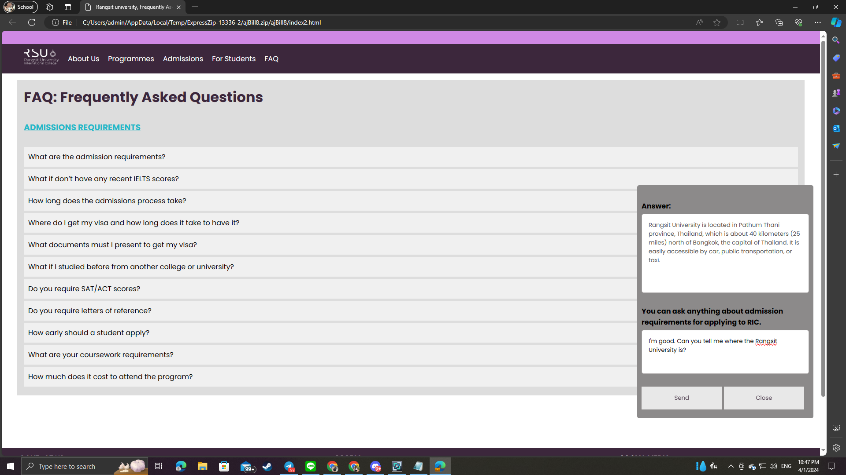
Fig1. Usability Testing
In the figure above, the user could greet and ask the chatbot about the location of the university and it answered the location exactly in just a second. So, our system also provides the instructions of the location or any area that the user wants to know.
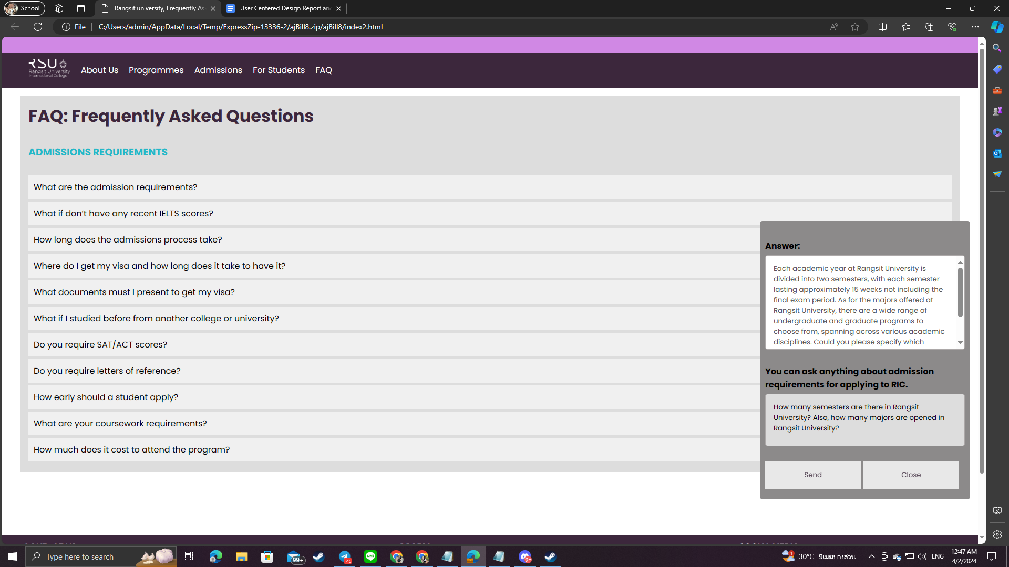
Fig2. Usability Testing
In the second figure, another user asked about the semesters and majors that exist in the university. The system answers the user’s questions with the instructions of semesters and majors in university which are useful for new students. There is no limit for questions to ask in the chatbot because the system will provide even more information for the user.
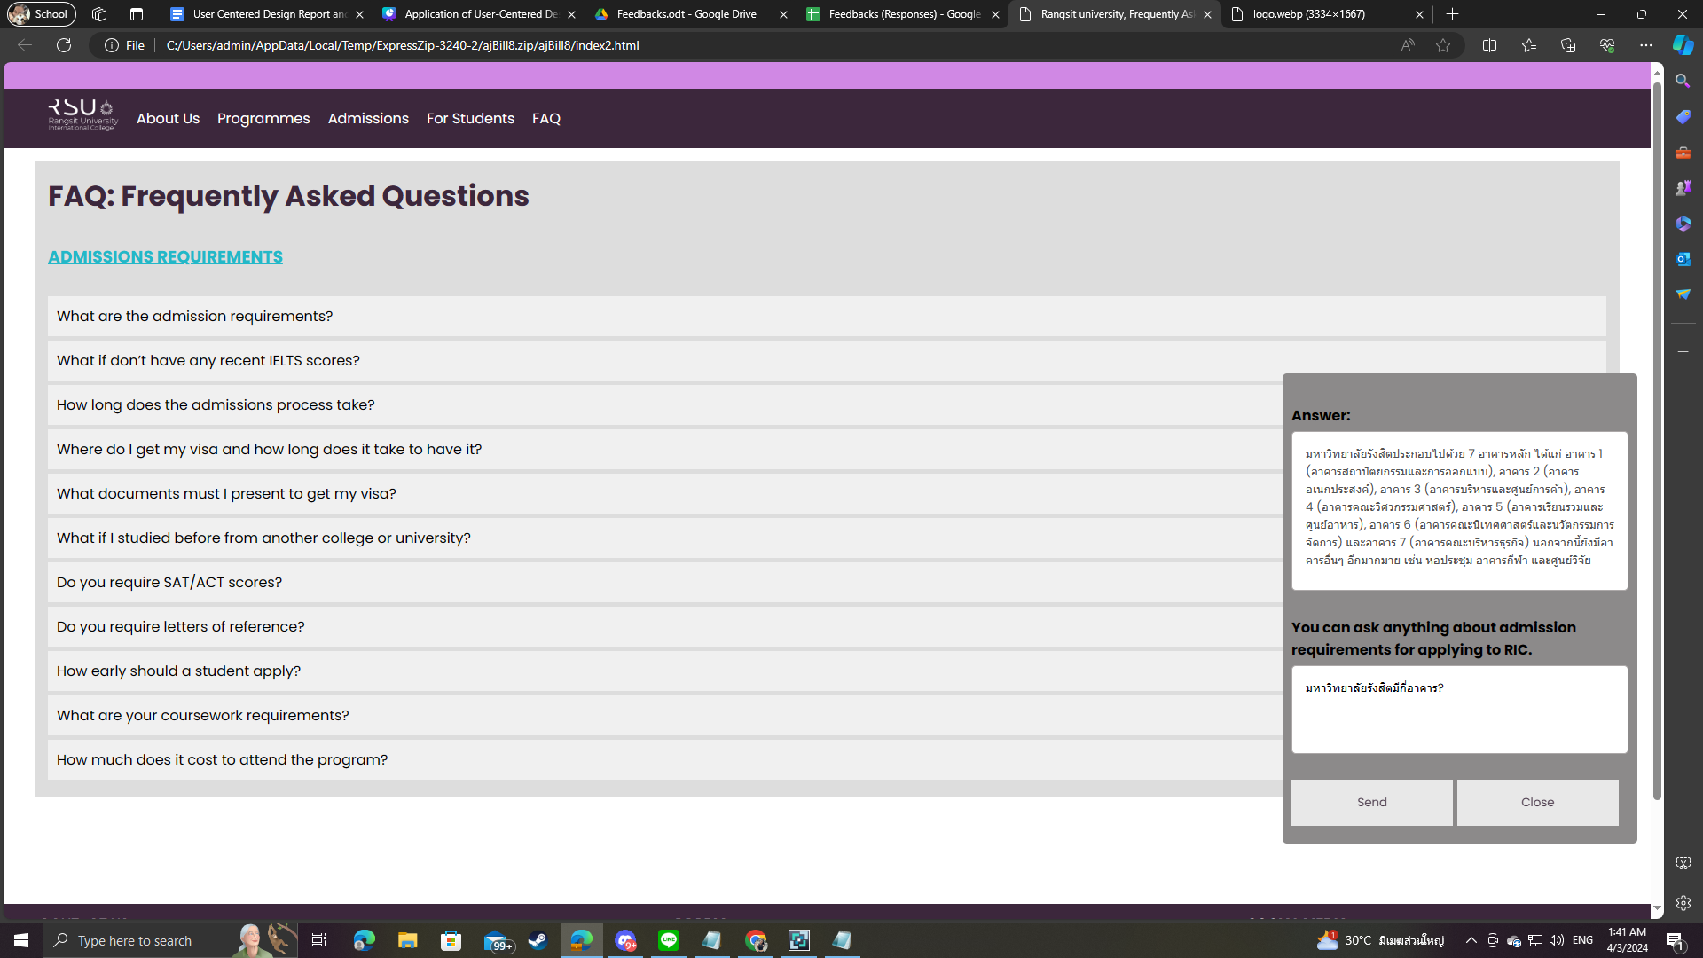
Fig3. Usability Testing
In the third figure shown above, a user can ask any other language if the user is an international student. The API will reply with the same language with a definite answer that the user asks.
8.Evaluate and Refine
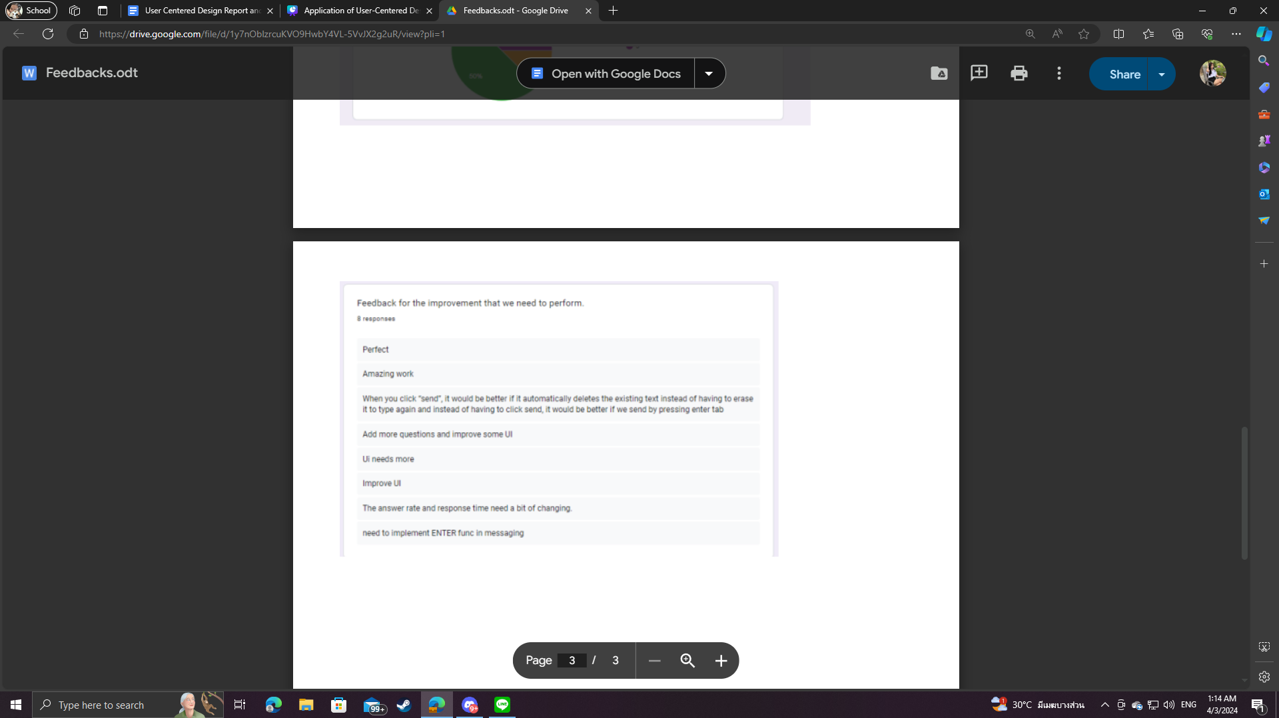
After reviewing the Rangsit University FAQ page, it's clear we need to improve some of the user experience for students. Key priorities are better navigation and making sure all sections have useful information. Feedback from different people has shown us what needs fixing. Now, we're working on making those improvements to create a FAQ page that meets everyone's needs and makes them happier with the university website. Moreover, our project aimed to restrict user access to a limited set of responses from the Gemini API.

Fig4. Survey Feedback
Feedback from our survey highlights key areas for improving our FAQ page and messaging system. Users want a more intuitive interface, suggesting UI enhancements and more questions to cover diverse queries. They also recommend streamlining messaging by enabling sending messages with the enter key and automatically clearing text upon sending. Respondents note that improving answer rate and response time would enhance user experience. These insights guide us in refining our systems to meet user expectations, improving usability and satisfaction.
To improve user experience and feedback, these are ways to make improvements for our FAQ page.
- Implement automatic text clearing upon clicking "send" to streamline messaging.
- Enable sending messages by pressing the enter key for intuitive user experience.
- Expand the number of questions available on the FAQ page to cater to a wider range of queries.
- Improve the user interface to enhance navigation and make it more intuitive.
- Optimize the answer rate and response time by refining backend systems for prompt and accurate responses to user inquiries.
9.Conclusion
In conclusion, our project focused on enhancing the FAQ page of Rangsit University to better meet the needs of students, parents, faculty, and other stakeholders. By implementing an AI-supported chatbot and refining the user interface, we aimed to provide faster response times and improve overall usability. Through user-centered design methodologies, including usability testing and feedback gathering, we identified key areas for improvement and iteratively refined our system to address user needs. The implementation of features such as automatic text clearing and enter key functionality, along with expanding the question database and optimizing response times, are steps towards creating a more intuitive and efficient FAQ page. These efforts contribute to enhancing user satisfaction and ensuring a positive experience for all users of the university website.

